Lewes FC Supporters Club

Annual Membership Report

2025
LFC Supporters Club Executive Committee (2025)

Chair – Barry Collins; bazzacollins@gmail.com
Vice-chair – Barry Haffenden; kinghuffles@gmail.com
Secretary – Mike Wallis; mikewallis11@gmail.com
Treasurer – Alan Sayers; alan.sayers1950@gmail.com
Membership Secretary – Jeff Sheldon; jandrewsheldon@gmail.com
Communications Manager – Barry Collins; bazzacollins@gmail.com

2025 At-a-Glance

Category | Metric
Supporters Club Committee meetings | 11 (1 AGM, 2 executive committee, 8 open)
Facebook members (End Q1 → End Q4) | 1,998 → 2,274 (+276)
Twitter/X followers (End Q1 → End Q4) | 1,383 → 1,364 (-19)
Bluesky members (End Q1 → End Q4) | 153 → 206 (+53)
Mailchimp subscribers (End Q1 → End Q4) | 379 → 396 (+17)
Facebook engagement totals (annual) | 1,644 posts; 5,847 comments; 21,523 reactions
Income (annual total) | £25,292.45
Quiz nights (n = 12) | £4,891
Expenditures (annual total) | £26,112.93
Donations to LFC (equipment/materials, etc.) | £18,000+
Net cash flow (annual total) | £-759.16
Year ending account balance | £11,367.82
Volunteer labour (estimated annual hours) | 3,635.25 hours
Community & Charitable Beneficiaries | 15+ local organisations
Estimated value of volunteer | £43,623 (£33,108 conservative estimate)

Executive Summary

This Annual Report consolidates quantitative results and qualitative narrative evidence across all four Lewes FC Supporters Club 2025 Quarterly Reports. By all accounts, 2025 was a year of sustained membership growth, strong financial stewardship, strong community engagement, and substantial volunteer commitment and contributions. Over the year the Club increased its overall membership reach, maintained exceptionally high levels of volunteer participation (i.e., weekly Dripping Pan maintenance, supporting Matchday operations across men’s and women’s fixtures, and community events), and delivered and generated consistent fundraising income for both the football club and local charitable causes.

Facebook membership grew from 1,945 at the end of 2024 to 2,274 by December 2025 (+329, +16.9%). Bluesky emerged as a meaningful additional platform, while Mailchimp subscriptions increased steadily and engagement remained strong with open rates frequently exceeding 50% across the year. As expected, Twitter/X showed a gradual decline mirroring wider platform trends. Throughout the year Facebook engagement exceeded hundreds of posts per quarter, with tens of thousands of page views and consistent demographic patterns.

Financially, across all four quarters, the Supporters Club generated in excess of £25,000 in income through matchday fundraising, quizzes, sponsored events, and community activities. Expenditure patterns reflect both routine operating costs and deliberate strategic investments including significant one-off donations to Lewes FC, and for club-designated Dripping Pan projects of over £18,000. The year closed with a stable account balance of £11,367.82.

Volunteer labour remained the Supporters Club’s largest non-cash contribution. Based on reported
maintenance totals, scheduled Matchday volunteer hours, and recorded community activity hours, a conservative annual estimate is 3,635.25 total volunteer hours. At £12.00/hour (conservative valuation), this equates to approximately £43,623 (conservatively, £30,888) of community value.
In 2025 the defining features of Supporters Club culture remained its vital role in maintaining the Dripping Pan, supporting Lewes FC financially, and strengthening local charitable networks. Evidence from social media narratives, volunteer reflections, and event write-ups highlight a strong sense of belonging, inclusivity, humour and camaraderie, transparent governance, civic pride, and historical stewardship.

1. Supporters Club Committee Meetings

Throughout 2025, the Supporters Club held 11 regular committee meetings, including the AGM and a mix of open and small executive committee sessions. Meetings were predominantly hybrid, supporting both in‑person and online participation, and were well attended across the year with attendance typically in the mid-teens to mid-twenties. Across quarters, meeting notes and minutes indicate an active governance culture focused on practical decision-making (finances, fundraising priorities, major purchases/donations, and operational support for the Dripping Pan) and the Club’s relationship with Lewes FC. The consistent presence of agendas/minutes in the quarterly records indicates transparency, continuity in club administration, and sustained member engagement.

2. Supporters Club Membership by Platform

Membership data show steady growth across digital platforms led by Facebook and supported by gradual increases in Mailchimp subscriptions with open rates regularly exceeding 50%, indicating a highly engaged core membership. Facebook membership rose each quarter, with the most pronounced gains in Q2 and Q4, growing from 1,998 at the end of Q1 to 2,274 by year-end, with consistently high posting, commenting, and reaction volumes across all quarters driven primarily by members. Engagement demographics were stable, with strongest participation among men aged 55–64 and women aged 45–54. While the Supporters Club’s base remains strongly UK-based, international engagement continued to modestly expand, reinforcing Lewes FC’s identity as a community club with global reach; the United States, Nigeria, and Indonesia were consistently represented. Bluesky, introduced late in 2024, continued to grow in both membership and posting activity, indicating successful experimentation with alternative platforms. Twitter/X experienced a modest decline in followers reflecting broader platform dynamics rather than reduced engagement. Overall, communications reach expanded and diversified across 2025. Overall, qualitative narratives emphasized humour, storytelling, historical continuity, and recognition of volunteer contributions as central to the Club’s communications strategy.

Membership by Platform

Platform | End Q1 | End Q2 | End Q3 | End Q4 | Net | % Change
Facebook | 1,998 | 2,100 | 2,172 | 2,274 | +276 | +13.8%
Twitter/X | 1,383 | 1,376 | 1,367 | 1,364 | -19 | -1.4%
Bluesky | 153 | 171 | 189 | 206 | +53 | +34.6%
Mailchimp | 379 | 401 | 390 | 396 | +17 | +4.5%

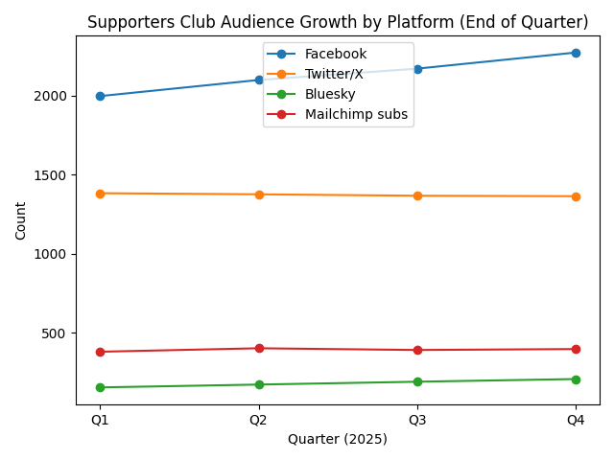
Figure 1. Supporters Club audience growth by platform (end-of-quarter totals across 2025).

3. LFC Supporters Club Facebook Engagement

As noted, Facebook remained the central hub of supporter interaction. Quarterly engagement levels were consistently high, with hundreds of posts and thousands of comments and reactions recorded in each quarter. Member-generated content accounted for the majority of activity, while a small number of visitor posts often generated disproportionately high interaction. Across quarters, the narrative evidence indicates that member-driven content accounted for the overwhelming majority of posts, comments, and reactions. Weekend peaks (particularly Sundays and Saturdays) recur, consistent with match schedules and club-event timing. Engagement patterns were stable across the year, with participation skewing male and strongest engagement among men aged 55–64 and women aged 45–54. Geographic data consistently placed Lewes at the centre of activity, with sustained regional and international reach.

Facebook Engagement

Quarter | Posts | Comments | Reactions
Q1 | 415, | 1,188 | 4,702
Q2 | 339 | 1,315 | 5,193
Q3 | 483 | 1,620 | 6,483
Q4 | 407 | 1,724 | 5,145
2025 Total | 1,644 | 5,847 | 21,523

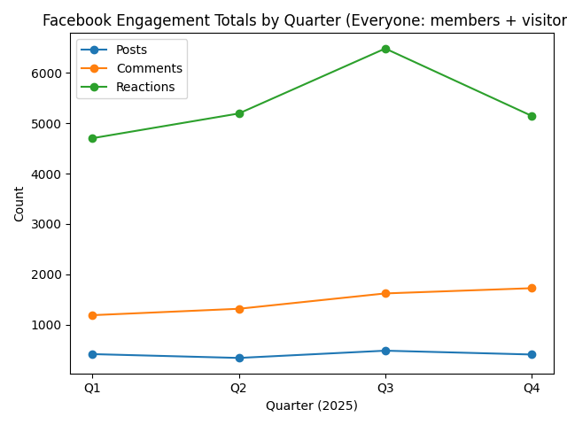
Figure 2. Facebook engagement totals by quarter (posts, comments, reactions; everyone—members + visitors).

4. Dripping Pan Maintenance and Equipment Expenditure

Expenditure on Dripping Pan maintenance varied by quarter, reflecting the episodic nature of capital works. Q1 included substantial infrastructure spending, while Q2 and Q3 focused on incremental improvements. No cash expenditure was recorded in Q4. Despite this variation in spending, qualitative evidence shows uninterrupted maintenance activity, demonstrating the importance of volunteer labour in sustaining the ground.

Dripping Pan Maintenance Expenditures

Quarter | Expenditures by Quarter | Projects Across Quarters
Q1 | £6,581.13 | - Improved access past the new unisex toilet block deposit  - Water supply installed at the 3G  - New door and window for the tea/coffee hut  - Drainage materials to install new drains for changing rooms and kitchen  - Water heater and air fryer  - Door closures  - Splash backs for hand driers and basins in the unisex toilets  - Donation to Louise for costs of plants for garden adjacent to players steps  - Paint and brushes for painting wheelchair areas  - Bird spikes to keep birds from perching on roofs, etc.  - Paint for access doors  - Paint for main entrance/exit doors  - Product dispensers/products for Ladies toilets
Q2 | £1,038.17
Q3 | £323.01
Q4 | £0
2025 Total | £7,942.31

5. Other Supporters Club Volunteer Lewes Community Activities

The Supporters Club played an active role in Lewes community life throughout 2025. Quiz nights, bingo events, sponsored walks, along with Lewes Food Bank collections raised significant funds (~£6,147) for local charities and community organisations. Recorded volunteer hours understate the true level of effort, as preparation time for various events is not fully captured. Narrative accounts emphasise strong partnerships with local businesses and venues reinforcing the Club’s role as a civic institution. Notably, the Supporters Club raised money for local charities, schools, wildlife rescue organisations, hospices, and community facilities. Quiz nights and bingo events were particularly effective, serving both as fundraising mechanisms and as inclusive social spaces that strengthened local ties. Qualitative narratives consistently describe the Supporters Club as a civic anchor within Lewes, blending sport, volunteering, humour, and local identity into a coherent community presence.

6. Dripping Pan Maintenance Volunteers

Maintenance volunteering followed a consistent weekly pattern throughout the year with estimated weekly totals typically around 26 person-hours when two maintenance days were delivered. Each quarter recorded approximately 300 or more person‑hours of labour, with an average of four volunteers per session, supplemented by additional regular contributions. Reported maintenance volunteer totals were: Q1 338 hours, Q2 338 hours, Q3 338 hours, and Q4 312 hours (annual total 1,326 hours).Estimated maintenance hours exceeded 1,300 person-hours. Volunteer labour frequently substituted for paid services substantially extending the Supporters Club’s operational capacity the Club’s financial impact.. Qualitative reflections highlight camaraderie, humour, and a strong sense of responsibility for the Dripping Pan as a shared community asset. Across quarters, the maintenance narratives emphasized a high level of practical stewardship: routine readiness tasks ahead of fixtures, ongoing cleaning, repairs, and improvements to facilities.

7. Fundraising and Expenditures by Source and Month

Fundraising income was generated through a diverse mix of matchday activities (e.g., raffles, golden goal), special events (e.g., golf day, sponsored walk, quiz and bingo nights, and seasonal raffle), and Pan 4 Gold. Monthly and quarterly net financial positions fluctuated with large outflows aligned with major one-off spending (e.g., donations to LFC and large purchases to and for Dripping Pan maintenance) and surpluses aligned with stronger matchday and event income. As such, income and expenditure varied by quarter as explained by the timing of fundraising events and match schedules with Q2 and Q3 recording net surpluses while Q1 and Q4 reflected net outflows. Over the year financial patterns suggest a balanced approach between deliberate reinvestment in the club and community rather than instability as supported by consistent grassroots fundraising. Total income recorded in 2025 was £25,292.45 with total expenditures of £26,112.93. Despite quarterly fluctuations (net cash flow across the year (sum of monthly net cash flow was £-759.16) the Supporters Club ended 2025 with a stable financial position given an ending account balance of £11,367.82 and a positive capacity to continue supporting club operations and community initiatives.
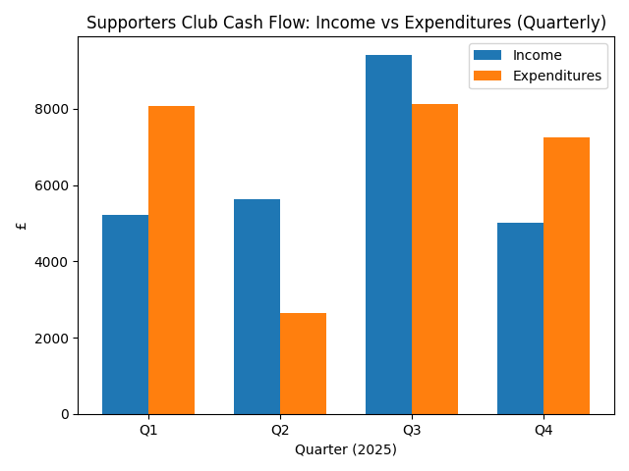
Figure 3. Supporters Club cash flow: income vs expenditures (quarterly totals).

8. Match‑day Volunteers, Operations, and Coverage

Matchday operations relied heavily on volunteer labour across men’s and women’s fixtures. Coverage of scheduled shifts was reliably consistent and well-coordinated, typically exceeding 90%, demonstrating but with occasional gaps in specific roles and several fixtures supported by paid staff for PA or other functions. Roles spanned season ticket gate, turnstiles, hospitality, raffles, PA announcer, and online commentary. While inclusive‑access measures were limited, overall matchday delivery was strong and dependable. Over the year, matchday data tables recorded 44 matches with total scheduled (estimated) matchday volunteer hours of 2,172.25 hours with an average of 49.37 hours per match. Coverage percentages varied by fixture but were generally high. Narrative notes also tracked community-access metrics (e.g., sponsored beach huts/community groups) which were limited throughout the year.

Matchday Coverage

Quarter | Matches | Avg Coverage | Volunteer Hours
Q1 | 11 | 94% | 540
Q2 | 12 | 96% | 612
Q3 | 11 | 95% | 510
Q4 | 10 | 93% | 510
2025 Total | 44 | 95% | 2,172

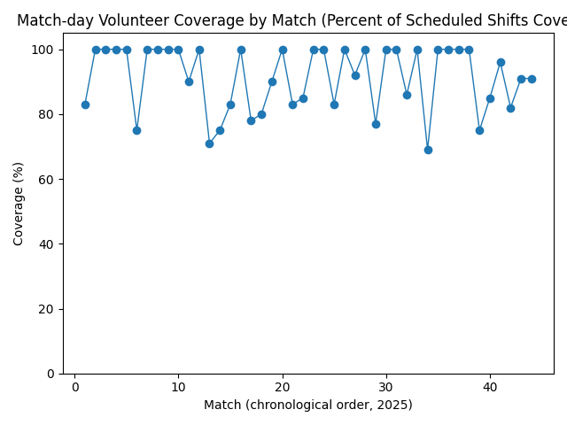
Figure 7. Matchday volunteer coverage by match (percent of scheduled shifts covered by volunteers; chronological order across 2025).

Value of Volunteering (Conservative £ Equivalent)

Maintenance (reported totals) contributed 1,326 hours, scheduled volunteers contributed 2,172.25 hours on matchdays, and community activity hours totalled an estimated 137 hours (note: some quarterly reports explicitly caution these hours are underestimates due to preparation time). In total, this yields a conservative annual estimate of 3,635.25 volunteer hours. Using a conservative valuation of £12.00 per hour, the estimated value of volunteer labour in 2025 is approximately £43,623. Across all four quarters the qualitative evidence repeatedly frames volunteer labour as the mechanism that makes Dripping Pan stewardship possible at scale: tasks are completed regularly and to a standard that would otherwise require paid support. Recognition, humour, and shared identity are recurring themes that appear to sustain this contribution over time.

9. A Moment in Club History…

Narrative contributions throughout the year connect current activity to the Supporters Club’s longer history. Stories of long‑serving volunteers, restored artefacts, and recognition of individual service reinforce a sense of continuity and collective memory. These moments do more than celebrate the past; they articulate shared values of care, humour, and community ownership that continue to shape the Club’s present and future.

